Name: |  |  | Date:
Class/Group:
Instructions to students: Please write answers in spaces provided.
Multiple choice questions |  |  |  | Marks
1 | An electric circuit is best described as:  A a path taken by electricity.  B the flow of electricity.  C something which will not conduct electricity.  D the force pushing electricity through a conductor.  Answer: A |  |  |  | 2
2 | An electrical insulator is best described as:  A a path taken by electricity.  B the flow of electricity.  C something which will not conduct electricity.  D the force pushing electricity through a conductor.  Answer: C |  |  |  | 2
3 | An electric current is best described as:  A a path taken by electricity.  B the flow of electricity.  C something which will not conduct electricity.  D the force pushing electricity through a conductor.  Answer: B |  |  |  | 2
4 | Which one of the following devices uses a voltage of about 12 volts?  A a toaster in the kitchen.  B a wristwatch.  C a motor car.  D a portable CD player.  Answer: C |  |  |  | 2
5 | Which one of the following devices uses a voltage of about 1 volt?  A a toaster in the kitchen.  B a wristwatch.  C a motor car.  D a portable CD player.  Answer: B |  |  |  | 2
6 | Which one of the following devices uses a voltage of about 240 volts?  A a toaster in the kitchen.  B a wristwatch.  C a motor car.  D a torch.  Answer: A |  |  |  | 2
7 | Alicia rubbed a perspex rod with a piece of cloth and observed that the cloth became positively charged. As a result of this, the perspex rod:  A became positively charged.  B became quite warm.  C became negatively charged.  D remained neutral.  Answer: C |  |  |  | 2
8 | Alicia rubbed a perspex rod with a piece of cloth and observed that the cloth became positively charged. What has been transferred from the rod to the material to cause this change?  A electrons.  B protons.  C neutrons.  D perspex molecules.  Answer: A |  |  |  | 2
9 | If only switches 2, 3 and 4 are closed, which bulbs will glow?  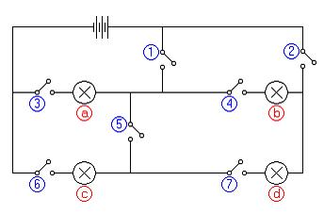  A c and d  B a and b  C a, b, c and d  D b and c  Answer: B |  |  |  | 2
10 | If only bulb ‘c’ glows, which switches would be closed?  A 2, 7 and 6  B 1, 5 and 6  C 1, 3 and 5  D 1, 3, 5 and 6  Answer: B |  |  |  | 2
11 | Which two bulbs are in parallel?  A a and b  B b and c  C c and d  D b and d  Answer: D |  |  |  | 2
12 | The switches are set up so that either bulbs ‘a’ and ‘b’ are glowing or ‘a’ and ‘c’ are glowing. If you compared the brightness of bulb ‘a’ when it was on with ‘c’ to when it was on with ‘b’, you would expect it to be:  A brighter.  B duller.  C barely visible.  D the same.  Answer: A |  |  |  | 2

Short answer questions |  |  | Marks
13 | The flow of electricity in a conductor can be compared to the flow of water in a pipe. Complete this statement by selecting the appropriate term from the list at right.  The pressure of the water may be compared to the:  Answer: voltage | Voltage  Current  Resistance  Power |  | 1
14 | The flow of electricity in a conductor can be compared to the flow of water in a pipe. Complete this statement by selecting the appropriate term from the list at right.  The amount of water per minute may be compared to the:  Answer: current | Voltage  Current  Resistance  Power |  | 1
15 | The flow of electricity in a conductor can be compared to the flow of water in a pipe. Complete this statement by selecting the appropriate term from the list at right.  Rust inside the pipe which slows down the water may be compared to the:  Answer: resistance | Voltage  Current  Resistance  Power |  | 1
16 | Indicate whether you would expect the objects shown to attract each other, repel each other, or have no effect.  Answer: no effect | 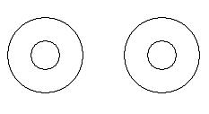 |  | 1
17 | Indicate whether you would expect the objects shown to attract each other, repel each other, or have no effect.  Answer: attract | 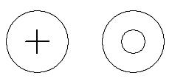 |  | 1
18 | Indicate whether you would expect the objects shown to attract each other, repel each other, or have no effect.  Answer: attract | 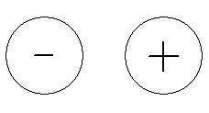 |  | 1
19 | Indicate whether you would expect the objects shown to attract each other, repel each other, or have no effect.  Answer: repel | 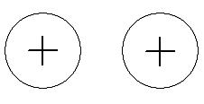 |  | 1
Long answer questions |  |  | Marks
20 | Using the proper symbols, design and draw a circuit in which two bulbs can be switched on and off separately. Say whether the bulbs are in series or parallel and explain why. Include a key showing each of the symbols you used and what they mean.  Answer: Possible arrangement as shown below, must be in parallel so as to provide alternative paths for the electricity.  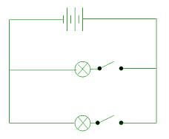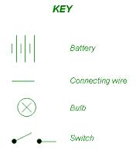 |  |  | 6
21 | In some sets of Christmas tree lights, if one light goes out they all go out. Draw a simple circuit to help you explain why this happens.  Answer: These bulbs are in series so all of the current passes through all of the bulbs. If one bulb blows, then no current can get through any of the bulbs and they all go out. It is like a switch.  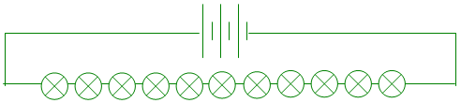 |  |  | 3
22 | In a motor car, even if one headlight ‘blows’ the other headlight, the radio or interior light will still work. Draw a simple circuit diagram to help you explain why this happens.  Answer: The different parts of the electrical system in a car are wired to the battery in parallel. If one goes off the others will not.  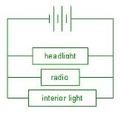 |  |  | 3
Practical questions |  |  | Marks
23 | (a) Use a sheet of paper to represent the floor plan of part of your house and on it draw the floor of your bedroom and another room nearby.  (b) Use 2 bulbs, 2 switches, a power source and several connecting wires to make a model to show how the lights in the two rooms can be switched on and off separately.  (c) When you have done this, show your teacher and then use the correct symbols to draw a circuit diagram for your model. |  |  | 14
Suggest
- 8 marks for construction and demonstration of the model as you require and
- 6 marks for a circuit diagram using correct symbols .

